**Baza e te dhenave per nje dyqan online (e-commerce)**

Ne vijim do te krijojme nje baze te dhenat per menaxhimin e punes se nje dyqani online

1. **Konceptimi i ER Diagram-it**

1. **Implementim i ER Diagram-it ne MySQL Workbanch**

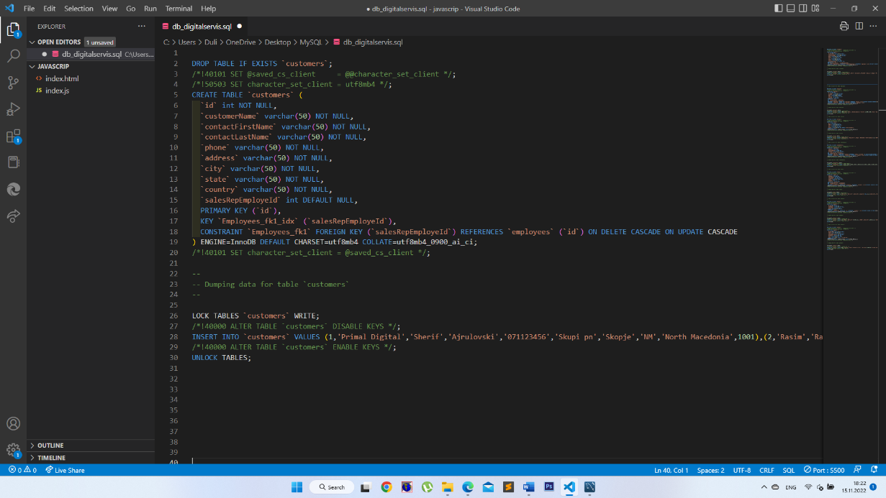

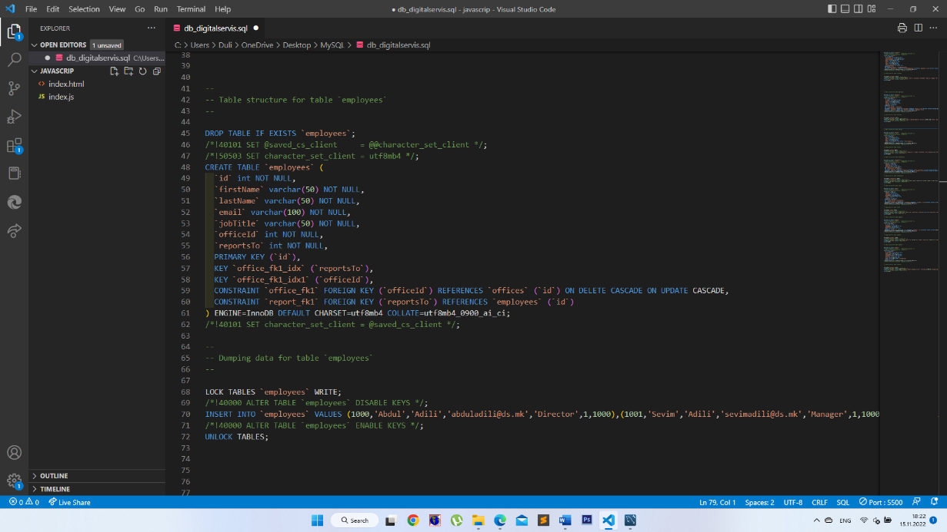

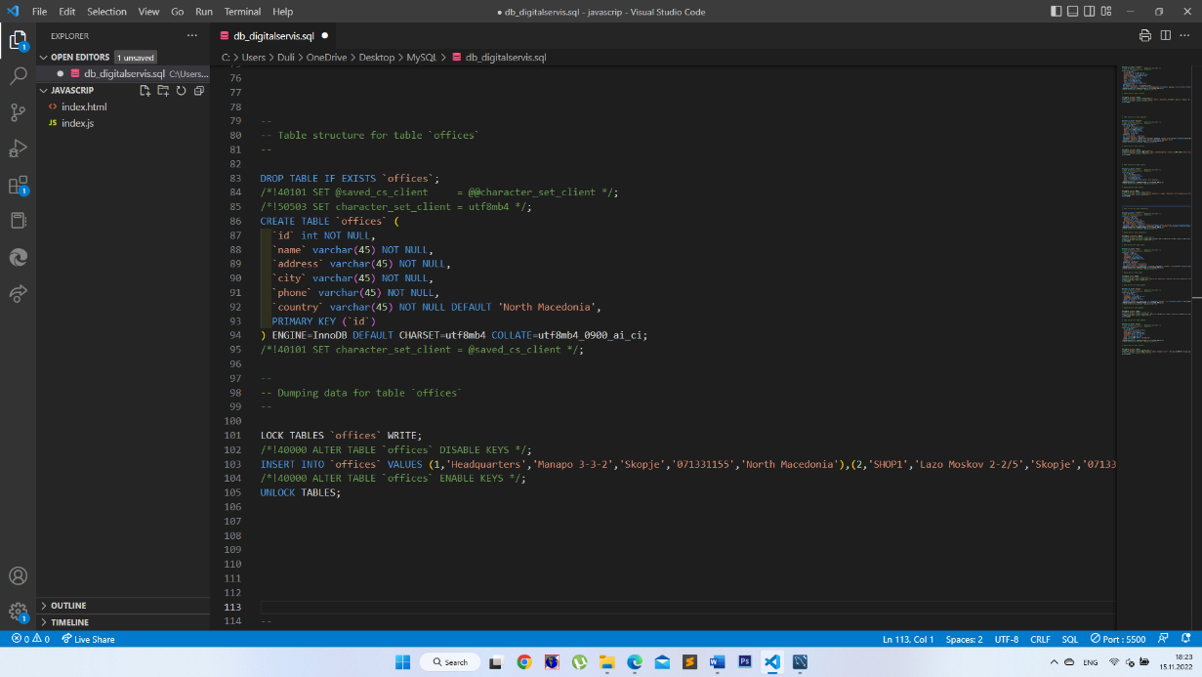

1. **Populimi i tabelave me te dhena**

I mbushim tabelat dhe pivot tabelat me te dhenat perkatese – ne menyre qe te marrim rezultate nga pyetesoret.

Orders Detail

INSERT INTO `db_digitalservis`.`orderdetails` (`orderId`, `productId`, `quantityOrdered`, `priceEach`) VALUES ('1', '1013', '100', '6')

INSERT INTO `db_digitalservis`.`orderdetails` (`orderId`, `productId`, `quantityOrdered`, `priceEach`) VALUES ('1', '1013', '100', '6')

INSERT INTO `db_digitalservis`.`orderdetails` (`orderId`, `productId`, `quantityOrdered`, `priceEach`) VALUES ('2', '1013', '100', '6')

INSERT INTO `db_digitalservis`.`orderdetails` (`orderId`, `productId`, `quantityOrdered`, `priceEach`) VALUES ('3', '1013', '100', '6')

INSERT INTO `db_digitalservis`.`orderdetails` (`orderId`, `productId`, `quantityOrdered`, `priceEach`) VALUES ('4', '1013', '100', '6')

INSERT INTO `db_digitalservis`.`orderdetails` (`orderId`, `productId`, `quantityOrdered`, `priceEach`) VALUES ('5', '1013', '100', '6')

INSERT INTO `db_digitalservis`.`orderdetails` (`orderId`, `productId`, `quantityOrdered`, `priceEach`) VALUES ('6', '1013', '100', '6')

INSERT INTO `db_digitalservis`.`orderdetails` (`orderId`, `productId`, `quantityOrdered`, `priceEach`) VALUES ('7', '1013', '100', '6')

INSERT INTO `db_digitalservis`.`orderdetails` (`orderId`, `productId`, `quantityOrdered`, `priceEach`) VALUES ('8', '1013', '100', '6')

INSERT INTO `db_digitalservis`.`orderdetails` (`orderId`, `productId`, `quantityOrdered`, `priceEach`) VALUES ('9', '1013', '100', '6')

INSERT INTO `db_digitalservis`.`orderdetails` (`orderId`, `productId`, `quantityOrdered`, `priceEach`) VALUES ('10', '1013', '100', '6')

INSERT INTO `db_digitalservis`.`orderdetails` (`orderId`, `productId`, `quantityOrdered`, `priceEach`) VALUES ('10', '1013', '100', '6')

Peyment

INSERT INTO `db_digitalservis`.`payments` (`id`,`customerId`, `checkNumber`, `paymentDate`, `amount`) VALUES ('1','6', 'CHK001', '2022-11-07', '700')  
INSERT INTO `db_digitalservis`.`payments` (`id`,`customerId`, `checkNumber`, `paymentDate`, `amount`) VALUES ('2','7', 'CHK002', '2022-11-07', '120')  
INSERT INTO `db_digitalservis`.`payments` (`id`,`customerId`, `checkNumber`, `paymentDate`, `amount`) VALUES ('3','5', 'CHK003', '2022-11-15', '1680')  
INSERT INTO `db_digitalservis`.`payments` (`id`,`customerId`, `checkNumber`, `paymentDate`, `amount`) VALUES ('4','4', 'CHK004', '2022-11-09', '240')  
INSERT INTO `db_digitalservis`.`payments` (`id`,`customerId`, `checkNumber`, `paymentDate`, `amount`) VALUES ('5','5', 'CHK005', '2022-11-15', '1000')  
INSERT INTO `db_digitalservis`.`payments` (`id`,`customerId`, `checkNumber`, `paymentDate`, `amount`) VALUES ('6','2', 'CHK006', '2022-11-12', '400')  
INSERT INTO `db_digitalservis`.`payments` (`id`,`customerId`, `checkNumber`, `paymentDate`, `amount`) VALUES ('7','1', 'CHK007', '2022-11-12', '1250')  
INSERT INTO `db_digitalservis`.`payments` (`id`,`customerId`, `checkNumber`, `paymentDate`, `amount`) VALUES ('8','9', 'CHK008', '2022-11-15', '1900')  
INSERT INTO `db_digitalservis`.`payments` (`id`,`customerId`, `checkNumber`, `paymentDate`, `amount`) VALUES ('9','3', 'CHK009', '2022-11-15', '300')

1. Queries

SELECT * FROM customers WHERE `salesRepEmployeId` = 1000

SELECT * FROM customers WHERE `salesRepEmployeId` = 1002

SELECT * FROM customers WHERE city = 'Skopje'

SELECT * FROM employees WHERE jobTitle = 'Sales'

SELECT * FROM orders WHERE shippedDate = '2022-11-15'

SELECT * FROM products WHERE categoryName = 'Notebooks'

SELECT * FROM orderdetails od JOIN products p ON od.productId = p.id

SELECT * FROM customers c JOIN payments p ON c.id = p.customerId

SELECT * FROM customers c JOIN payments p ON c.id = p.customerId WHERE amount > 500

SELECT * FROM customers c JOIN payments p ON c.id = p.customerId order by amount desc

SELECT count(*) from employees

SELECT customerName, city, count(*) from customers group by City

SELECT productId, quantityOrdered FROM orderdetails GROUP BY productId ORDER BY quantityOrdered desc LIMIT 3

SELECT productId, productName, quantityOrdered FROM products INNER JOIN orderdetails ON products.id = orderdetails.productid GROUP BY productId ORDER BY quantityOrdered desc LIMIT 5